1. User defined variables.

**Best practice is to use variables in curly brackets. i.e. {}**

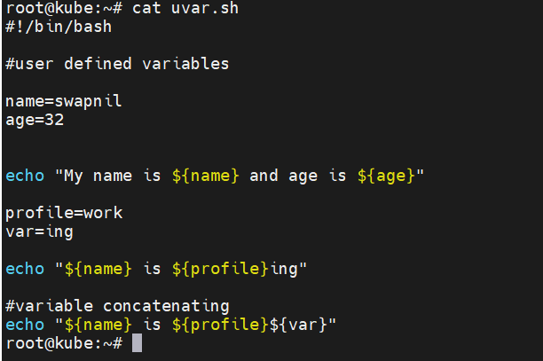

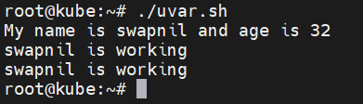

1. Variables are case sensitive. i.e. NAME, name both are different variables & print the value accordingly.
2. Variable names can’t be reserved words. Variable name can’t have whitespace in between. Can’t have special characters. The first character of the variable name can’t be a number.